ENVIRONMENTS

Definitions

Habitat: place where a plant or animal lives.

Population: a group of organisms of the same species living in the same area.

Community: different groups of organisms that live together in a particular habitat.

Environment: all the conditions in a habitat that affect the survival of an organism.

Biotic factors: living factors that shape an environment.

e.g. Predators, parasites, availability of food, disease.

Abiotic factors: non-living factors that shape an environment.

e.g. Temperature, water, wind, light, soil fertility, wave action and tides.

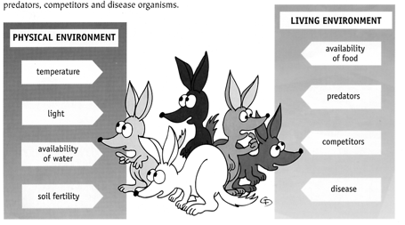

Ecology: study of interactions between living things and their environment.

Ecosystem: complex system of feeding relationships and interactions with abiotic
factors.

The diagram below represents a food web showing the feeding relationships in a community.

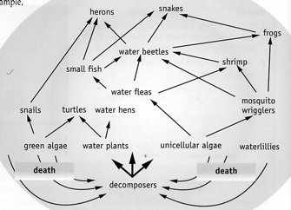

Adaptation: any feature of an organism that helps it survive and reproduce in the
environment.

e.g. Eagles have claws adapted for gripping prey from the ground.
Kangaroos have long tails for balance when hopping.

Types of Physical Environments

Aquatic

Factors that affect survival in water.

• Amount of O₂ in the water.
• Temperature.
• Amount of light available.
• Effect of currents and waves.
• Effect of buoyancy.

Land

Factors that affect survival on land.

• Structures to absorb O₂ (e.g. lungs, gills).
• Skeleton to support muscles.
• Excessive water loss.
• Regulating temperature of the body.

